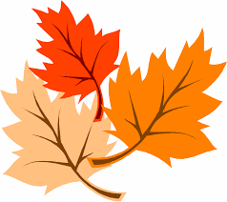

Please Join Us!
It’s Spring Clean Up Time
at the Community Library

What: We will be cleaning up outside and inside

When: Sunday May 22
9:00am to 12:00pm

Where: 10 John Street, Lyman

We need your help with gardening, washing windows, painting, dusting and more.
Please help clean up the library
It’s a great time to earn your community service hours.

